Light Intensity Changing Using Arduino

Description:
The Light Intensity Changing project demonstrates how the brightness of an LED can be controlled smoothly using a potentiometer.
In this project, a B10k potentiometer is used as an input device to vary voltage, while an Arduino processes this input and adjusts the LED brightness using Pulse Width Modulation (PWM).
This project is useful for understanding analog input, PWM output, and basic brightness control applications.

Block Diagram:
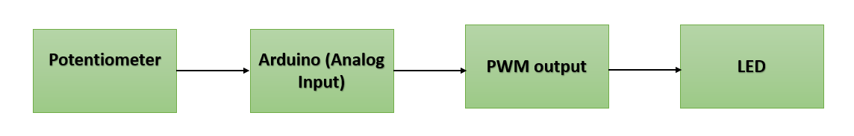

Pinout / Circuit Connection:
- Potentiometer Middle Pin → Arduino A0
- Potentiometer Side Pin 1 → Arduino 5V
- Potentiometer Side Pin 2 → Arduino GND
- Arduino PWM Pin (D9) → LED Anode
- LED Cathode → GND (through resistor)

Components Required:
- Arduino Uno
- B10k Potentiometer
- LED
- 220Ω Resistor
- Breadboard
- Jumper Wires

Working Principle:
The potentiometer acts as a variable voltage divider.
When the knob of the potentiometer is rotated, the output voltage changes between 0V and 5V.
The Arduino reads this voltage using its analog-to-digital converter (ADC).
Based on the input value, the Arduino generates a PWM signal to control the LED brightness.
Higher PWM duty cycle increases brightness, while lower duty cycle reduces brightness.

Operation (Step-by-Step):
• Connect the potentiometer and LED as per the circuit diagram
• Upload the Arduino code to the board
• Rotate the potentiometer knob
• The analog value changes
• Arduino adjusts the PWM signal
• LED brightness increases or decreases smoothly

Arduino Code:
#define POT_PIN A0
#define LED_PIN 9

void setup() {
pinMode(LED_PIN, OUTPUT);
}

void loop() {
int potValue = analogRead(POT_PIN); // Read potentiometer (0–1023)
int brightness = map(potValue, 0, 1023, 0, 255); // Map to PWM range

analogWrite(LED_PIN, brightness); // Control LED brightness
delay(10);
}

Conclusion: (Predefined/self-written)
The Light Intensity Changing project effectively demonstrates analog input reading and PWM-based LED control using Arduino.
It helps students understand potentiometer operation, ADC conversion, and brightness control techniques.
This project forms the foundation for applications such as dimmers, lighting control systems, and user-input-based automation.

For Your References:
[1] M. Margolis, Arduino Cookbook, 2nd ed. Sebastopol, CA, USA: O’Reilly Media, 2011.
[2] A. P. Godse and D. A. Godse, Microcontrollers and Applications, Pune, India: Technical Publications, 2010.
[3] Arduino, “Analog Input and PWM Output,” Arduino.cc. [Online]. Available: https://www.arduino.cc/en/Tutorial/AnalogInput. [Accessed: Mar. 12, 2015].

